HARVELELECTRIC ELECTRONIC STORE

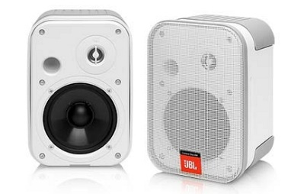

Sony HT-S350 2.1CH Speaker With Powerful Subwoofer And Bluetooth (White)

Brand: [Sony](https://www.jumia.com.ng/sony/)

**Price: $800**

Was ~~$1000~~ 54%

+ shipping only for V.V.I.P clients.

## **Product details**

* Powerful 320W of total output brings your content to life
* 2. 1Ch front Surround sound delivers clear audio
* Wireless subwoofer delivers deeper, richer sound
* S-force Pro front Surround creates a wide sound stage for cinematic audio
* Seven different sound modes to enhance your entertainment experience
* Voice Enhancement for greater clarity, Wall mount your sound bar to save space, Connect to your TV over a single cable with HDMI ARC, Easily connects with a range of TVs via Bluetooth, In the box: remote Commander (rmt-ah500u), batteries for remote Commander, Optical cable, wall Mount template, customer registration card, Card, quick setup guide, Instruction manual, Remote Commander (RMT-AH500U), Batteries for remote commander, Optical Cable, Wall Mount Template

## **Specifications**

## **KEY FEATURES**

* Powerful 320W of total output brings your content to life
* 2. 1Ch front Surround sound delivers clear audio
* Wireless subwoofer delivers deeper, richer sound
* S-force Pro front Surround creates a wide sound stage for cinematic audio
* Seven different sound modes to enhance your entertainment experience
* Voice Enhancement for greater clarity, Wall mount your sound bar to save space, Connect to your TV over a single cable with HDMI ARC, Easily connects with a range of TVs via Bluetooth, In the box: remote Commander (rmt-ah500u), batteries for remote Commander, Optical cable, wall Mount template, customer registration card, Card, quick setup guide, Instruction manual, Remote Commander (RMT-AH500U), Batteries for remote commander, Optical Cable, Wall Mount Template.

## **WHAT’S IN THE BOX**

REMOTE CONTROL, BATTERY, MANUAL

## **SPECIFICATIONS**

* **SKU**: SO521EL1I9S7QNAFAMZ
* **Product Line**: Sony Store
* **Model**: HT-S350
* **Production Country**: Malaysia
* **Weight (kg)**: 12.83
* **Color**: White
* **Display Size (inches)**: 41.0
* **Display Features**: Anti Glare